Open <https://lnx85-dev01:12081/tohindi> on browser

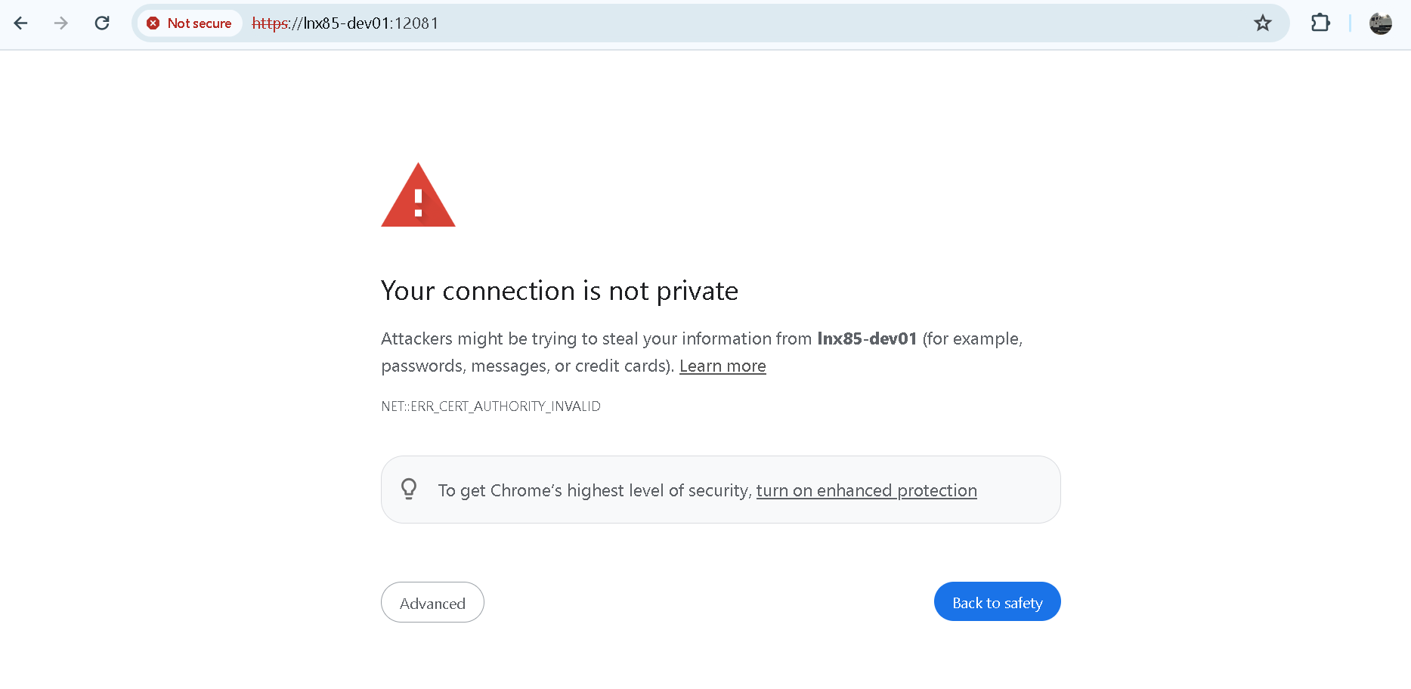

Click on Show advanced and click on proceed to lnx85-dev01.

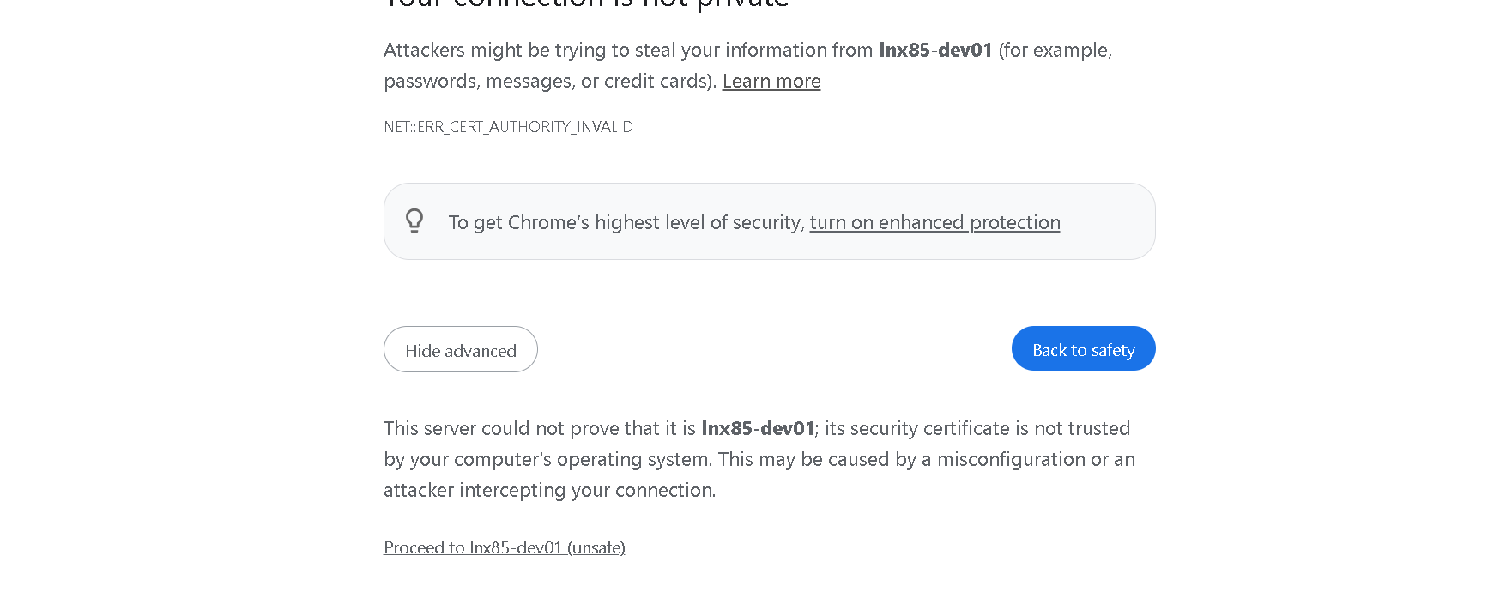

Click on Show advanced and click on proceed to lnx85-dev01.

Below page appears.

